**BY ROW INDEX:**

1. **First Name field value** for the first row by XPath  
   1. (//*[@role="columnheader"]/following::div[@class='rt-tr -even' or @class='rt-tr -odd']/div[@role='gridcell'][1])[1]  
   2. (//div[@class='rt-tr -odd' or @class='rt-tr -even' ])[1]/child::*[1]  
   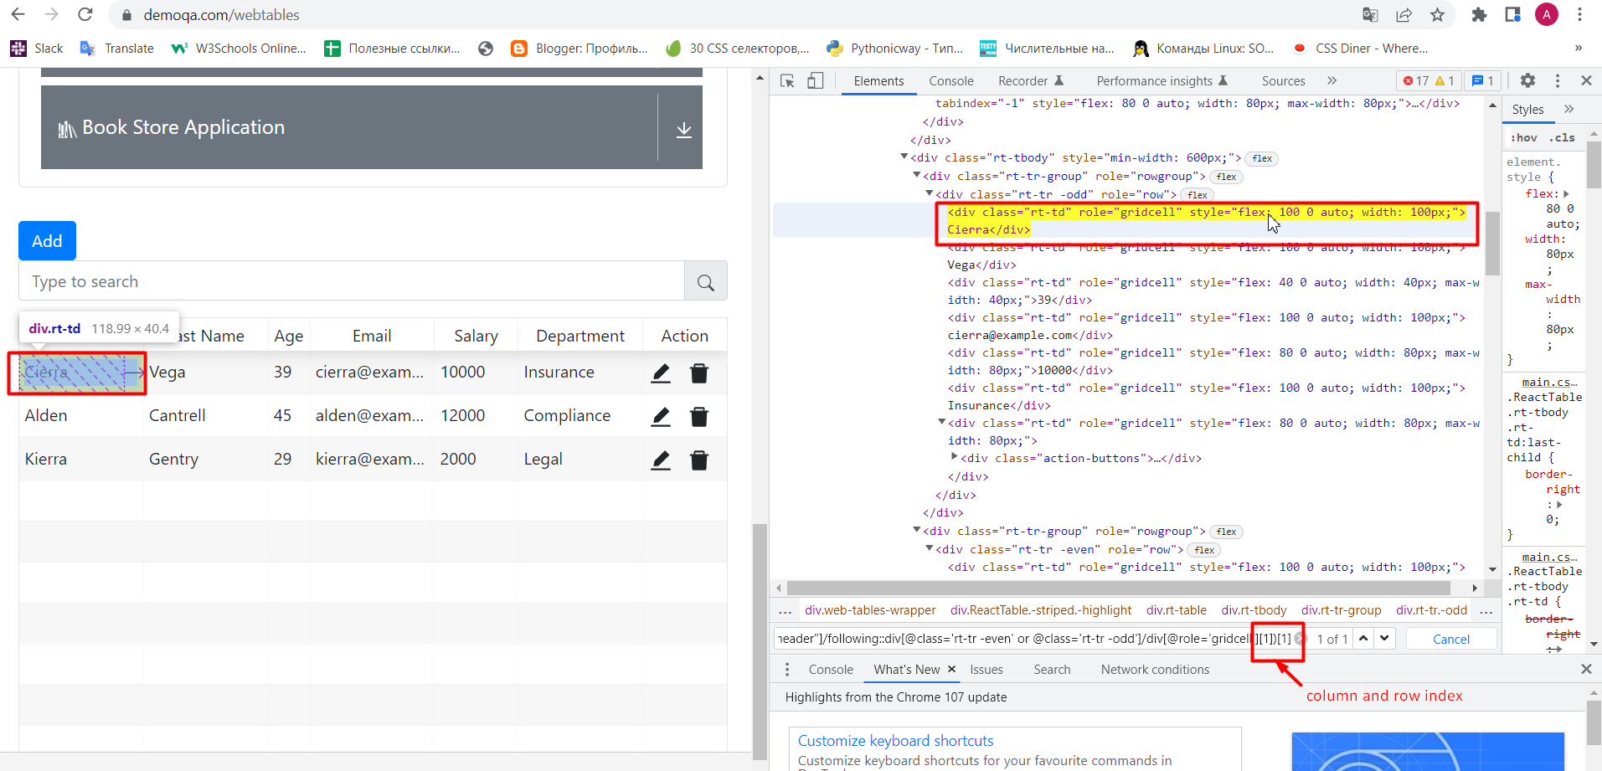
2. **Last Name field value** for the first row by XPath  
   1. (//*[@role="columnheader"]/following::div[@class='rt-tr -even' or @class='rt-tr -odd']/div[@role='gridcell'][2])[1]  
   2. (//div[@class='rt-tr -odd' or @class='rt-tr -even' ])[1]/child::*[2]

1. **Age field value** for the first row by XPath  
   1. (//*[@role="columnheader"]/following::div[@class='rt-tr -even' or @class='rt-tr -odd']/div[@role='gridcell'][3])[1]  
   2. (//div[@class='rt-tr -odd' or @class='rt-tr -even' ])[1]/child::*[3]

1. **Email field value** for the first row by XPath  
   1. (//*[@role="columnheader"]/following::div[@class='rt-tr -even' or @class='rt-tr -odd']/div[@role='gridcell'][4])[1]

2. (//div[@class='rt-tr -odd' or @class='rt-tr -even' ])[1]/child::*[4]  
  
1. **Salary field value** for the first row by XPath  
   1. (//*[@role="columnheader"]/following::div[@class='rt-tr -even' or @class='rt-tr -odd']/div[@role='gridcell'][5])[1]  
   2. (//div[@class='rt-tr -odd' or @class='rt-tr -even' ])[1]/child::*[5]

1. **Department field value** for the first row by XPath  
   1. (//*[@role="columnheader"]/following::div[@class='rt-tr -even' or @class='rt-tr -odd']/div[@role='gridcell'][6])[1]  
   2. (//div[@class='rt-tr -odd' or @class='rt-tr -even' ])[1]/child::*[6]  
   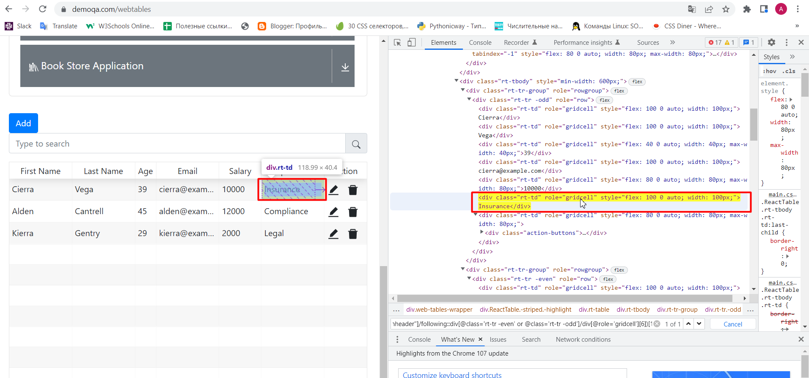
2. **Actions field EDIT value** for the first row by XPath  
   1. ((//*[@role="columnheader"]/following::div[@class='rt-tr -even' or @class='rt-tr -odd']/div[@role='gridcell'][last()])//span[@title='Edit'])[1]  
   2. (//div[@class='rt-tr -odd' or @class='rt-tr -even' ])[1]/child::*[7]//span[@title="Edit"]

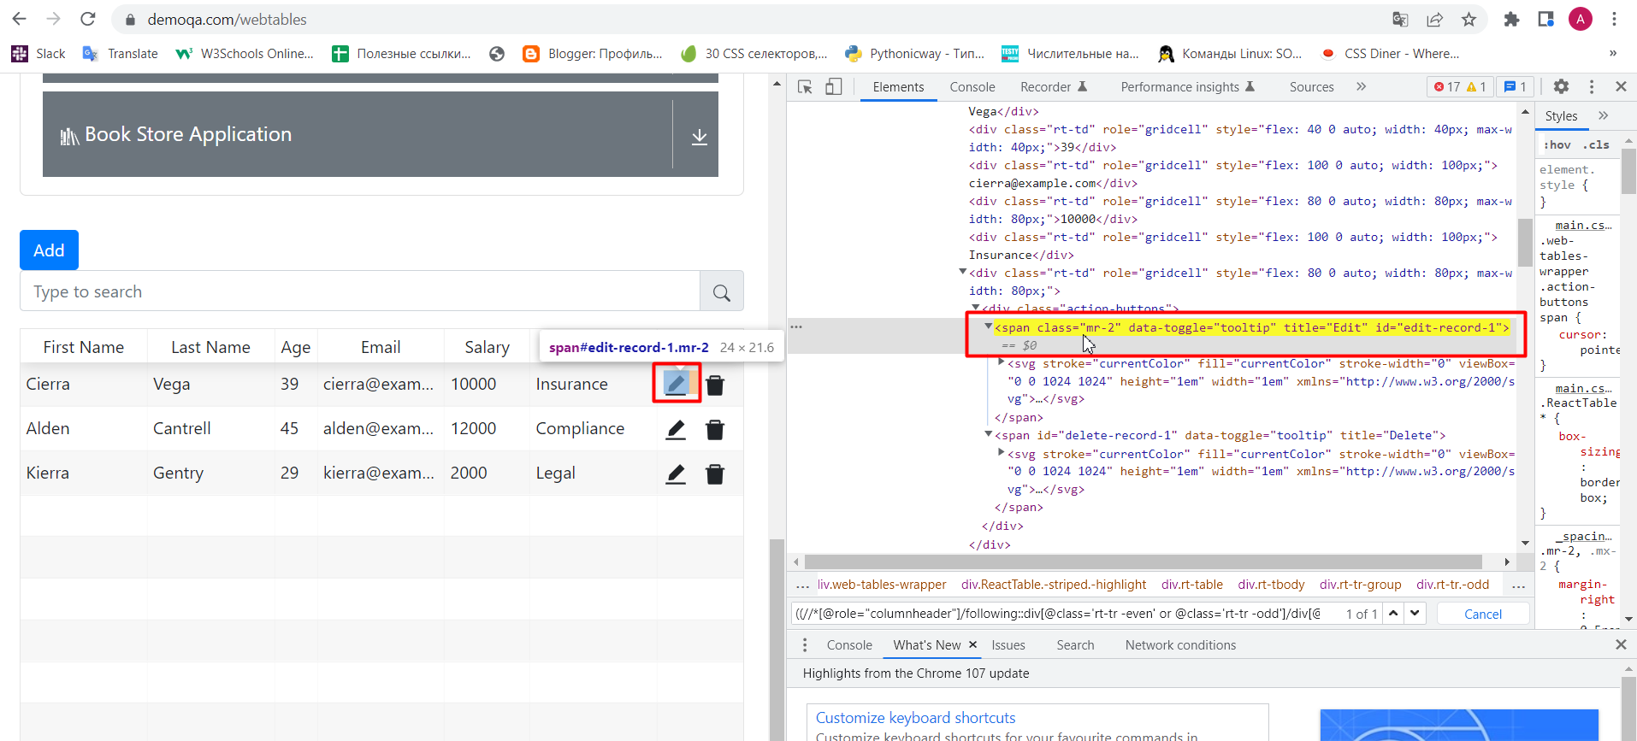

1. **Actions field DELETE value** for the first row by XPath  
   1. ((//*[@role="columnheader"]/following::div[@class='rt-tr -even' or @class='rt-tr -odd']/div[@role='gridcell'][last()])//span[@title='Delete'])[1]  
   2. (//div[@class='rt-tr -odd' or @class='rt-tr -even' ])[1]/child::*[7]//span[@title="Delete"]  
   Graphical user interface, application

   Description automatically generated

**BY EMAIL FIELD VALUE:**

1. **First Name field value** for the first row by XPath:  
   //div[contains(text(), 'cierra@example.com')]/ancestor::div[@role='row']/child::*[1]  
   Graphical user interface, text, application

   Description automatically generated
2. **Last Name field value** for the first row by XPath  
   //div[contains(text(), 'cierra@example.com')]/ancestor::div[@role='row']/child::*[2]  
   Graphical user interface, application

   Description automatically generated
3. **Age field value** for the first row by XPath  
   //div[contains(text(), 'cierra@example.com')]/ancestor::div[@role='row']/child::*[3]  
   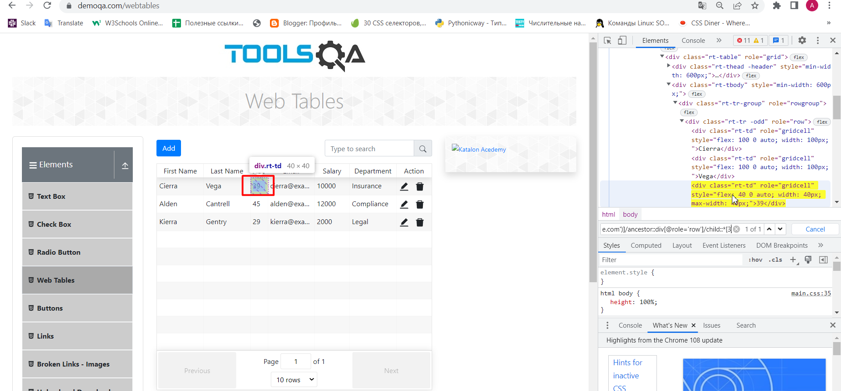
4. **Email field value** for the first row by XPath  
   //div[contains(text(), 'cierra@example.com')]/ancestor::div[@role='row']/child::*[4]  
   A screenshot of a computer

   Description automatically generated with medium confidence
5. **Salary field value** for the first row by XPath  
   //div[contains(text(), 'cierra@example.com')]/ancestor::div[@role='row']/child::*[5]Graphical user interface, application

   Description automatically generated
6. **Department field value** for the first row by XPath  
   //div[contains(text(), 'cierra@example.com')]/ancestor::div[@role='row']/child::*[6]  
   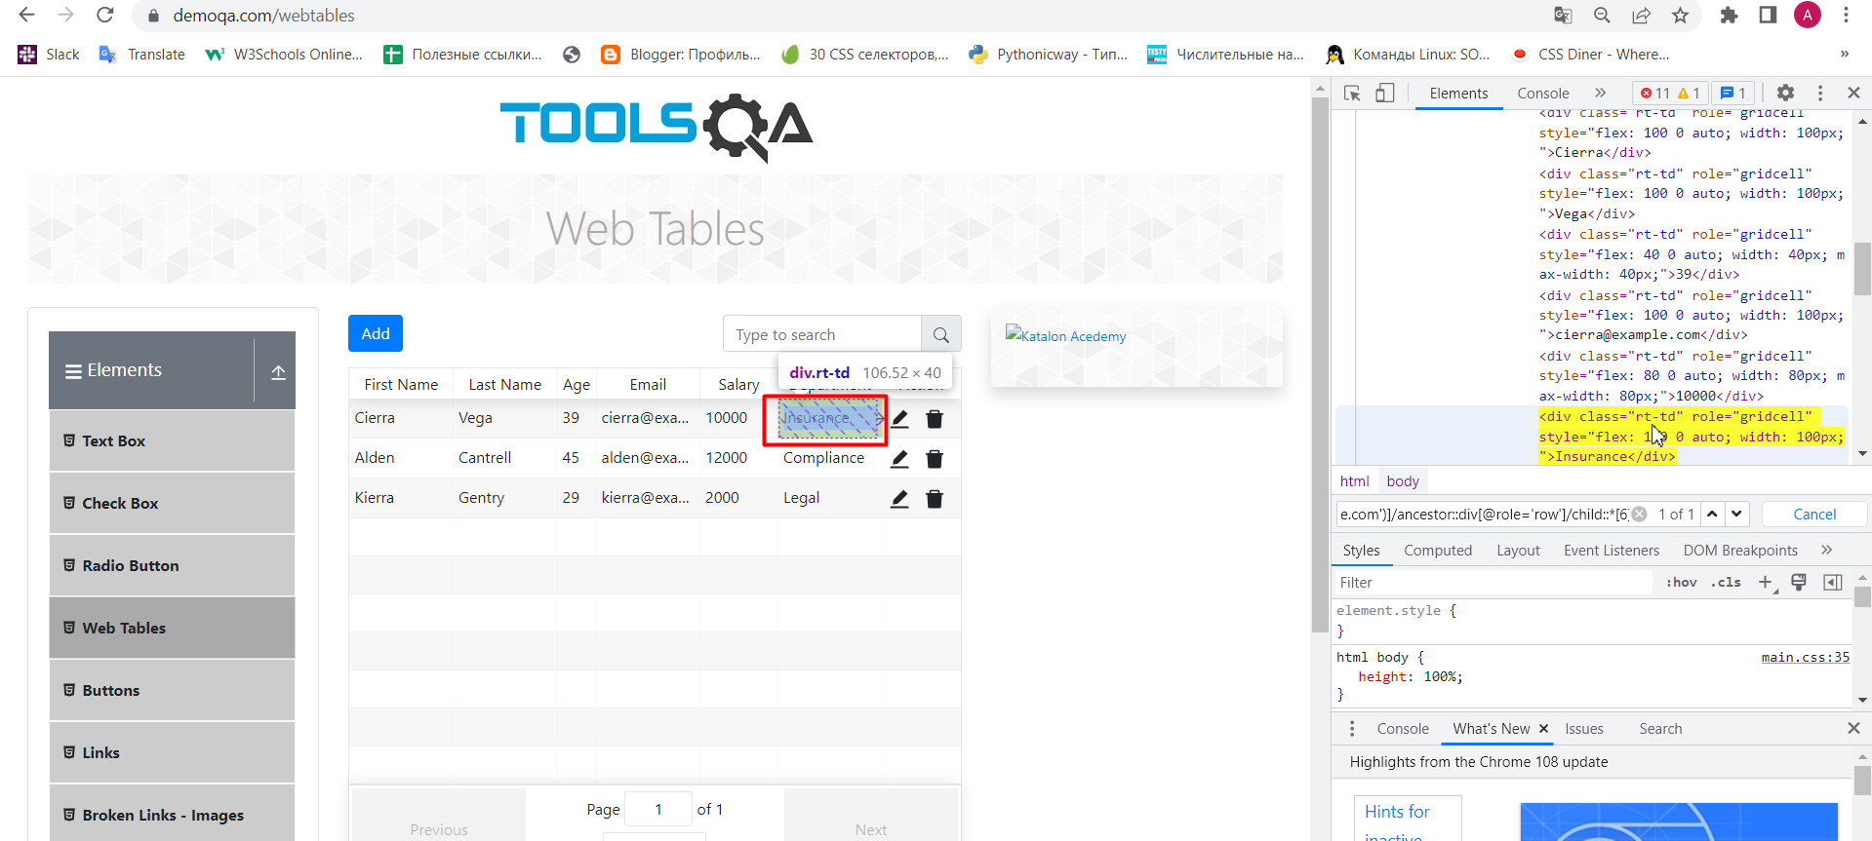
7. **Actions field EDIT value** for the first row by XPath  
   //div[contains(text(), 'cierra@example.com')]/ancestor::div[@role='row']/child::*[7]//span[@title="Edit"]  
   Graphical user interface, application

   Description automatically generated
8. **Actions field DELETE value** for the first row by XPath  
   //div[contains(text(), 'cierra@example.com')]/ancestor::div[@role='row']/child::*[7]//span[@title="Delete"]Graphical user interface, application

   Description automatically generated